Diaphragmatic Breathing
Benefits of Diaphragmatic Breathing:
Triggers relaxation response, facilitates grounding and centering in the moment (necessary for decreasing anxiety), promotes circulation throughout body (including the brain, which requires oxygenated blood in order to process thoughts & feelings), connects you to your body where you can gain awareness of your emotional state.
Diaphragmatic breathing technique
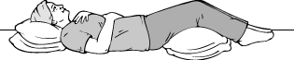
1. Lie on your back on a flat surface or in bed, with your knees bent and your head supported. You can use a pillow under your knees to support your legs. Place one hand on your upper chest and the other just below your rib cage. This will allow you to feel your diaphragm move as you breathe.
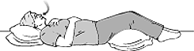
2. Breathe in slowly through your nose so that your stomach moves out against your hand.
The hand on your chest should remain as still as possible.
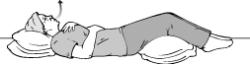
3. Tighten your stomach muscles, letting them fall inward as you exhale through your lips. The hand on your upper chest must remain as still as possible.
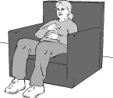
To perform this exercise while sitting in a chair:
1. Sit comfortably, with your knees bent and your shoulders, head and neck relaxed.
2. Place one hand on your upper chest and the other just below your rib cage. This will allow you to feel your diaphragm move as you breathe.
3. As you breathe in, feel your belly push out against your hand. As you breathe out, tighten your stomach muscles, letting them fall inward as you exhale through your mouth. The hand on your upper chest must remain as still as possible.
Note: You may notice an increased effort will be needed to use the diaphragm correctly. At first, you'll probably get tired while doing this exercise. But keep at it, because with continued practice, diaphragmatic breathing will become easy and automatic.

How often should I practice this exercise?
At first, practice this exercise 5-10 minutes about 3-4 times per day. Gradually increase the amount of time you spend doing this exercise, and perhaps even increase the effort of the exercise by placing a book on your abdomen.
Adapted from http://www.cchs.net/health/health-info/docs/2400/2409.asp?index=9445

